National Fruit Fly Symposium

Social media posts and images

23 June | 4 weeks to go until the #fruitflysymposium2023 in Adelaide! Be part of the conversation to discover tomorrow’s fruit fly solutions today.  Registration is essential, so don’t delay: https://ow.ly/ZHYb50OTlnO #preventfruitfly #fruitflysymposium2023 #viewoverthehorizon | 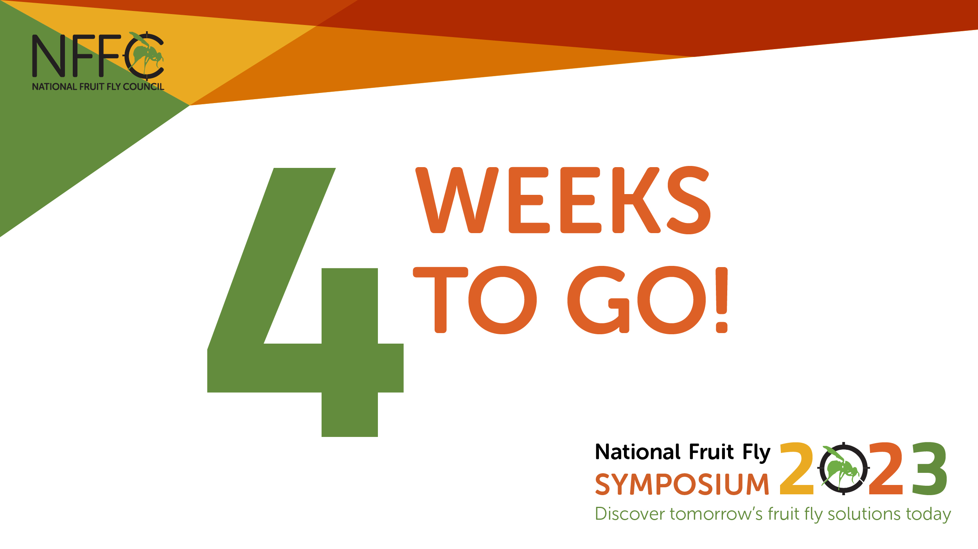
25 June | We are excited to announce the line-up of key participants that will lead discussions at the upcoming #fruitflysymposium2023. Join us for in-depth discussions on #fruitfly solutions. Register today: https://ow.ly/ZHYb50OTlnO #preventfruitfly #fruitflysymposium2023 #viewoverthehorizon | 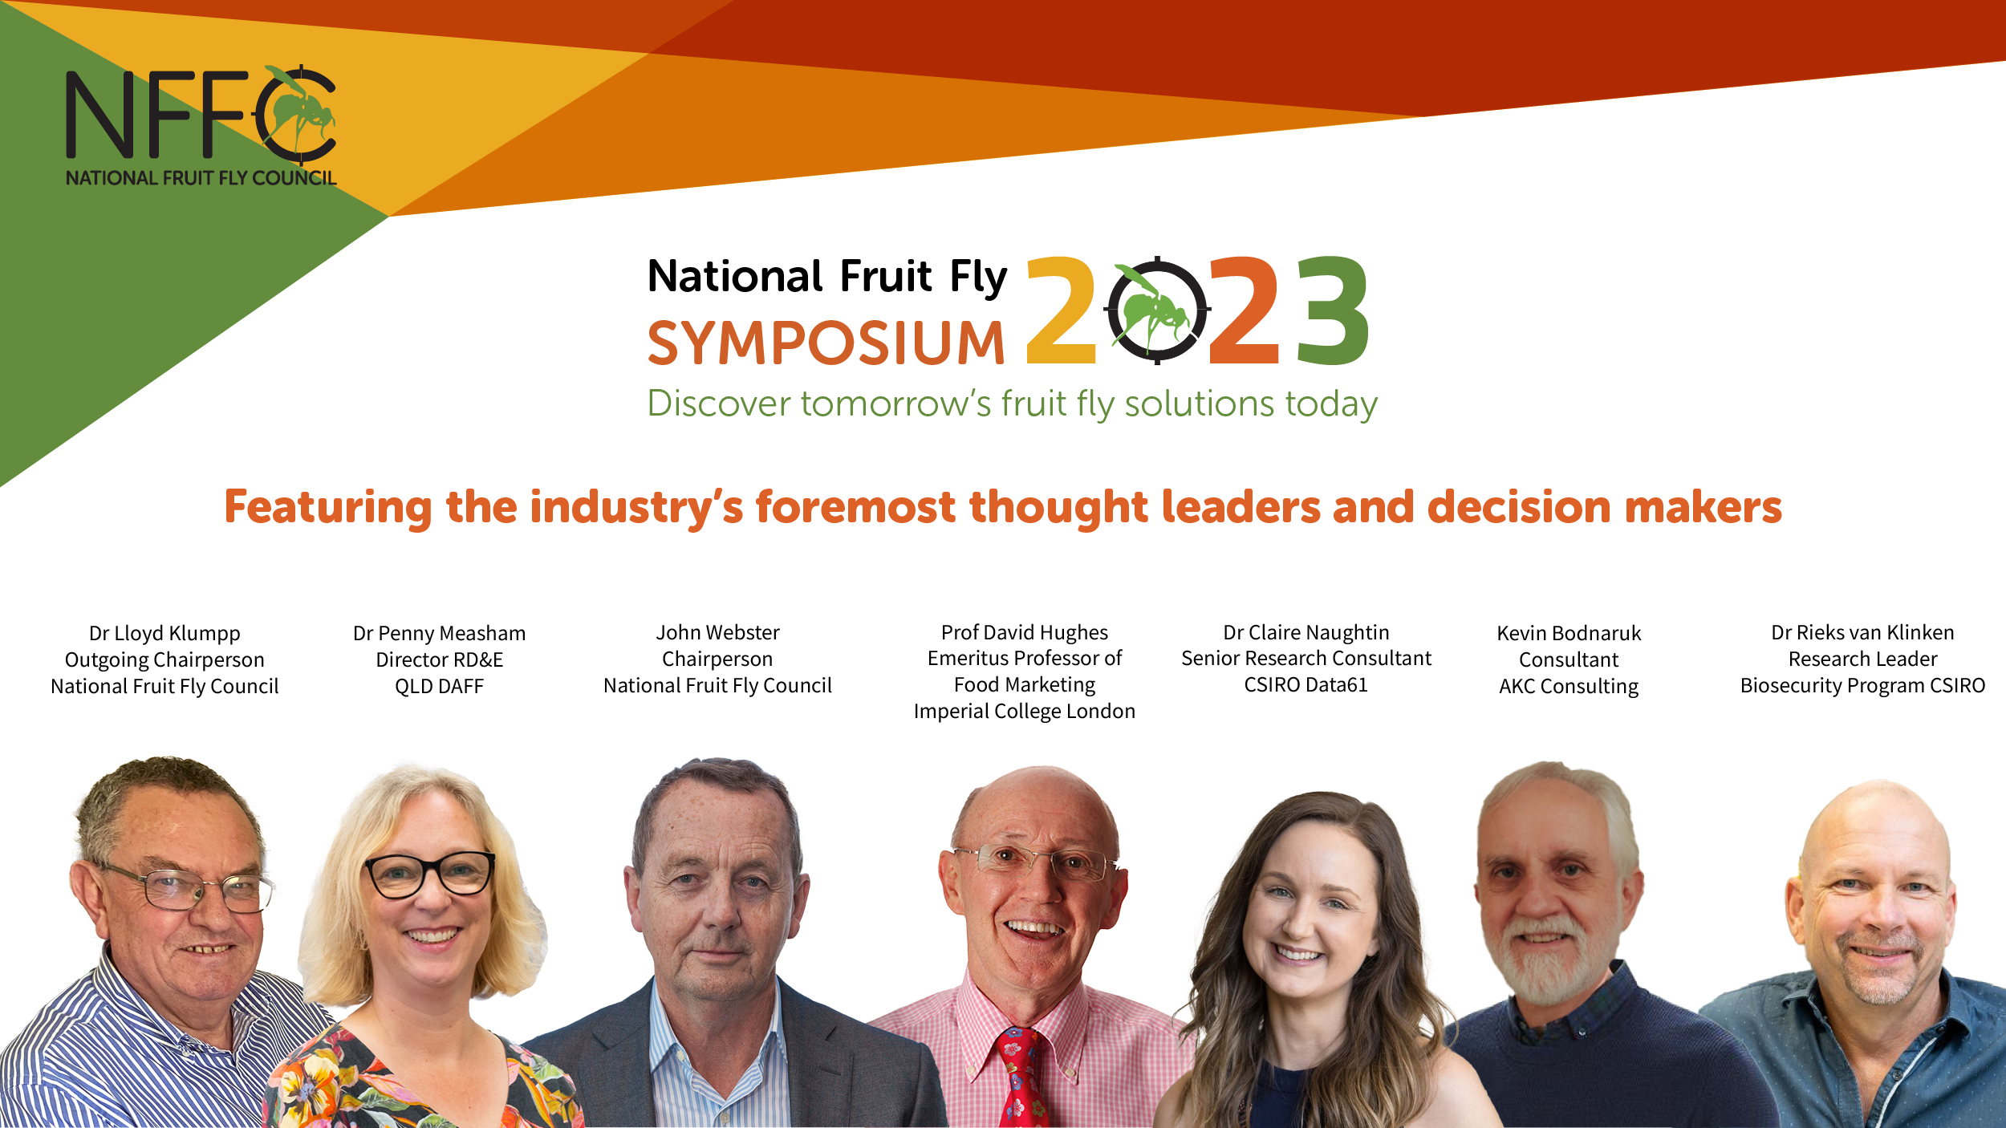
29 June | 3 weeks to go until the #fruitflysymposium2023 in Adelaide! The symposium from 20 - 21 July will provide an opportunity to listen, engage and contribute to our collective #fruitfly future. Space is limited, register now: https://ow.ly/ZHYb50OTlnO #preventfruitfly #fruitflysymposium2023 #viewoverthehorizon | 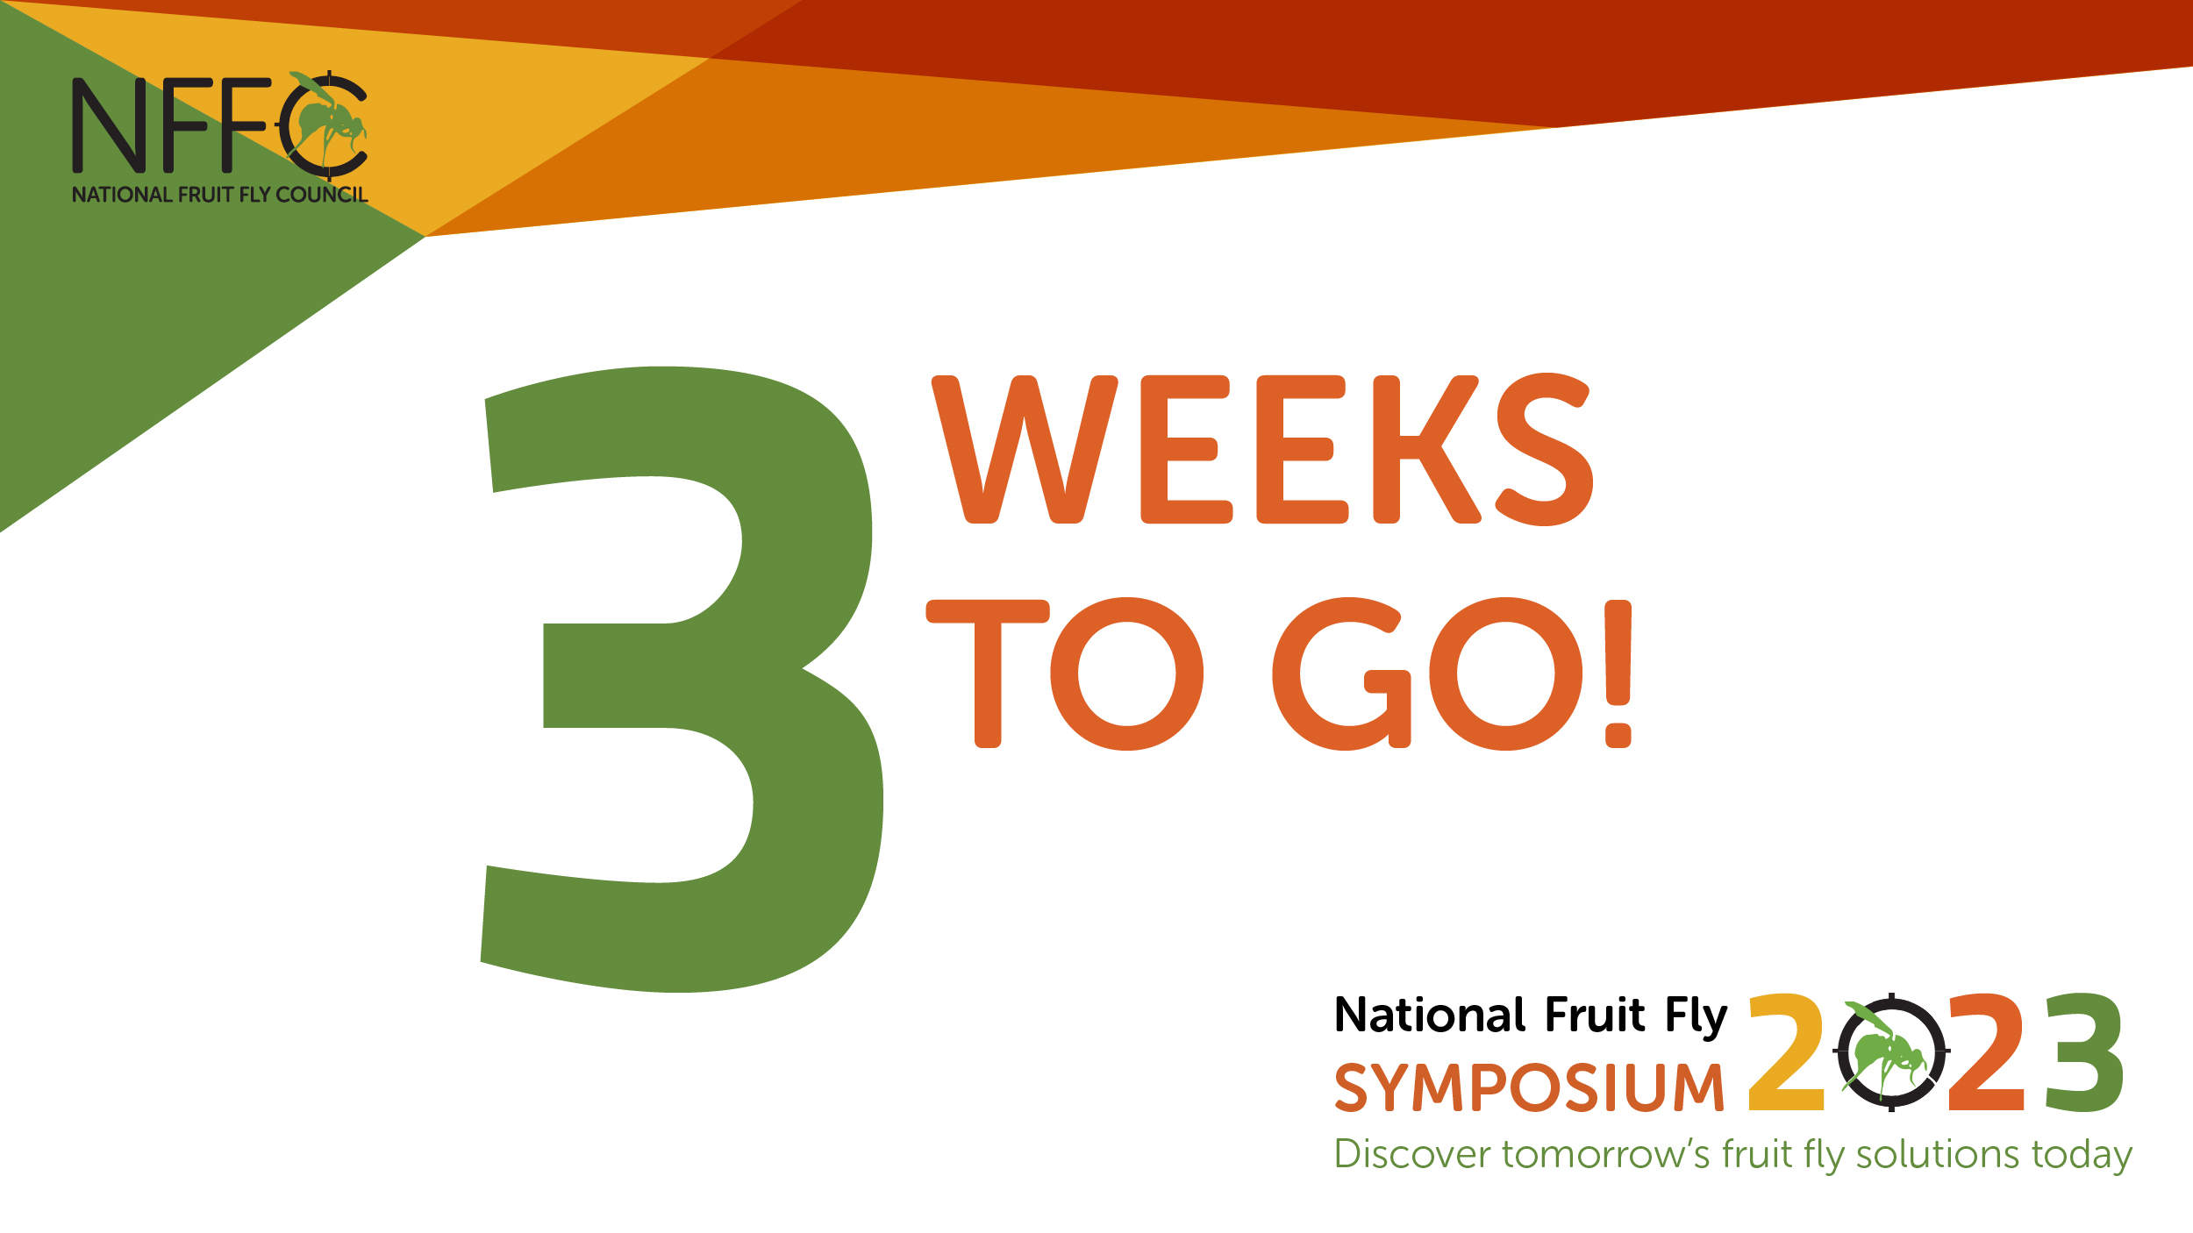
30 June | On Day 1 of the #fruitflysymposium2023 global expert Dr Claire Naughtin who co-author the 2022 CSIRO Our Future World megatrends report, will contextualise and set the scene. Register now: https://ow.ly/ZHYb50OTlnO #preventfruitfly #fruitflysymposium2023 #viewoverthehorizon | 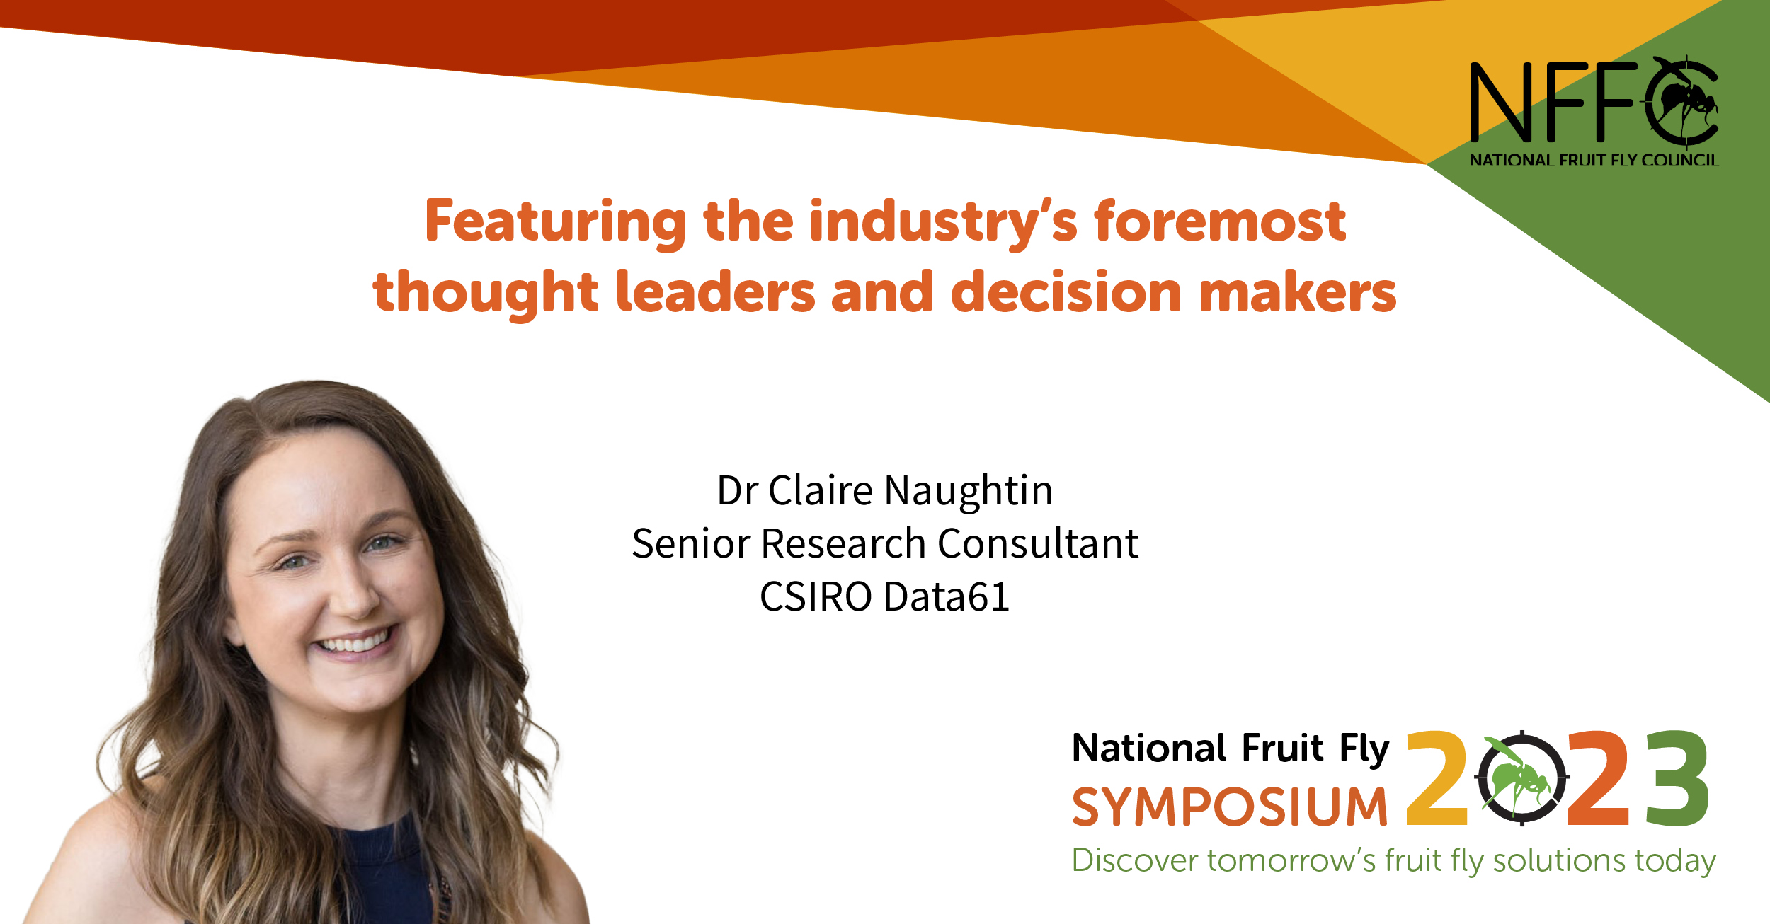
3 July | In less than 3 weeks the #fruitflysymposium2023 discussions will focus on market & economic imperatives for our horticultural industries to control #fruitfly. Join us: https://ow.ly/ZHYb50OTlnO #preventfruitfly  #viewoverthehorizon

5 July | We look forward to hear more from Prof David Hughs, an international expert in global food industry issues. He will join panel discussions on Day 1 of the #fruitflysymposium2023. Register now: https://ow.ly/ZHYb50OTlnO #preventfruitfly #viewoverthehorizon  @Hort_AU | 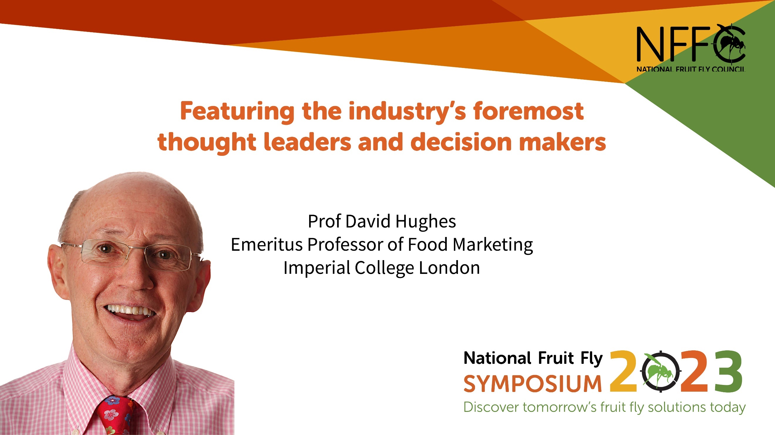
6 July | The clock is ticking! Two weeks to go until the #fruitflysymposium2023. Be part of this national conversation. Register now:  @Hort_AU | 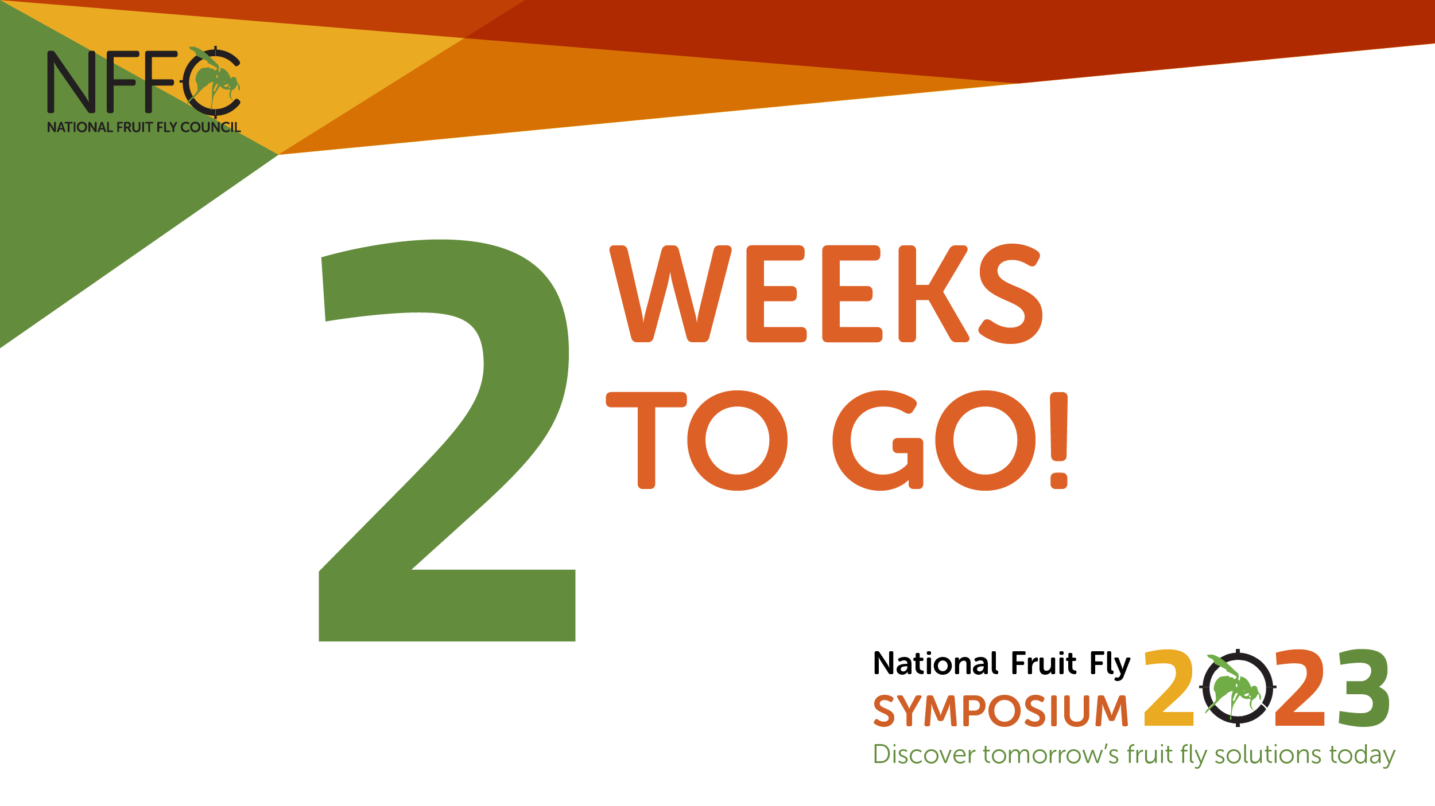
7 July | Dr Penny Measham, a #fruitfly market access expert from @QDAF, will join several panel discussion at #fruitflysymposium2023. Registration is essential: https://ow.ly/ZHYb50OTlnO #preventfruitfly #viewoverthehorizon  @Hort_AU | 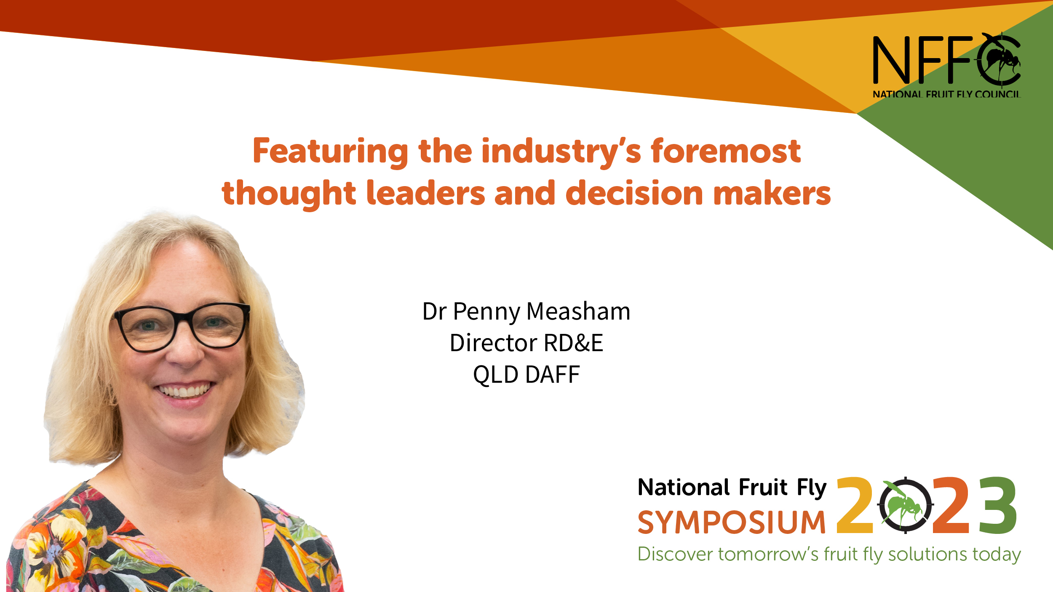
10 July | Experts in the areas of #agchem and alternate #fruitfly control methods, such as Kevin Bodnaruk, will explore future opportunities and priorities. Register now for the #fruitflysymposium2023: https://ow.ly/ZHYb50OTlnO #preventfruitfly #viewoverthehorizon  @Hort_AU | 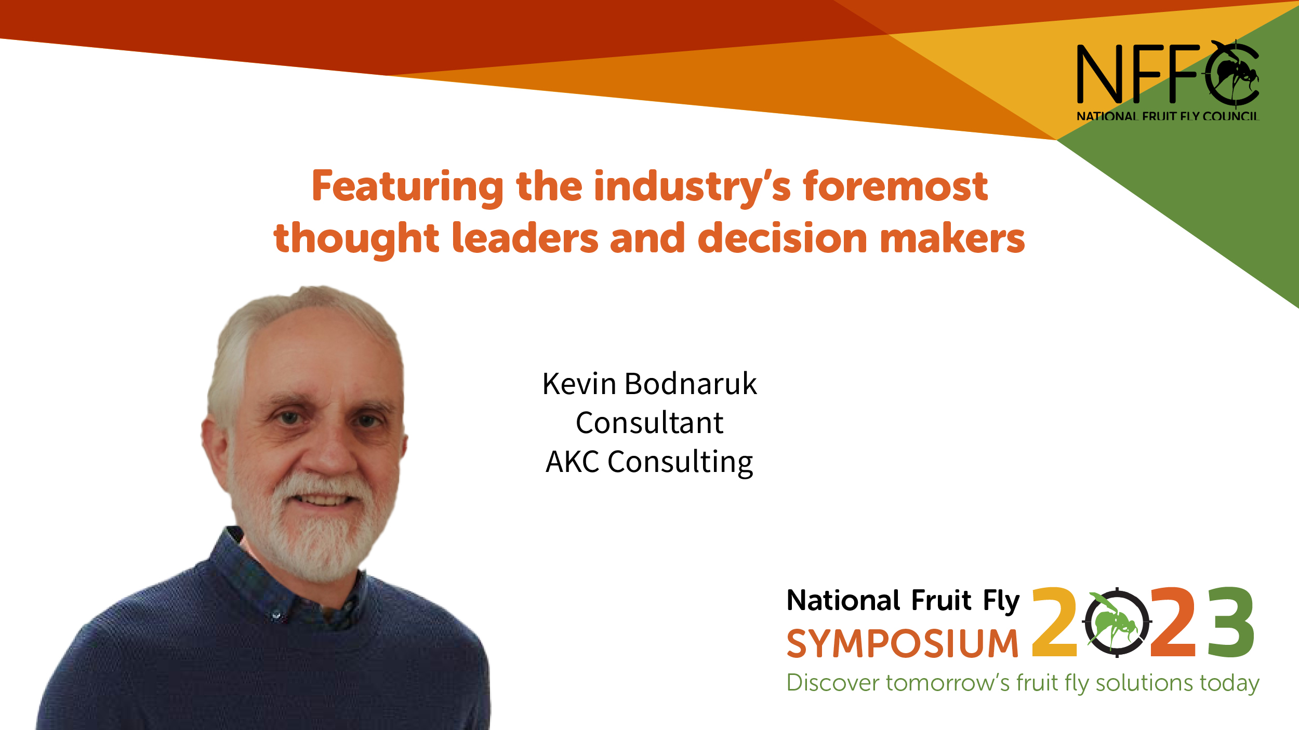
12 July | On Day 2 of the #fruitflysymposium2023, Dr Rieks van Klinken from @CSIRO will join a panel discussion about future control methods and options for the fruit fly management toolbox. Read more: https://bit.ly/3CJnSAW #preventfruitfly #viewoverthehorizon  @Hort_AU | 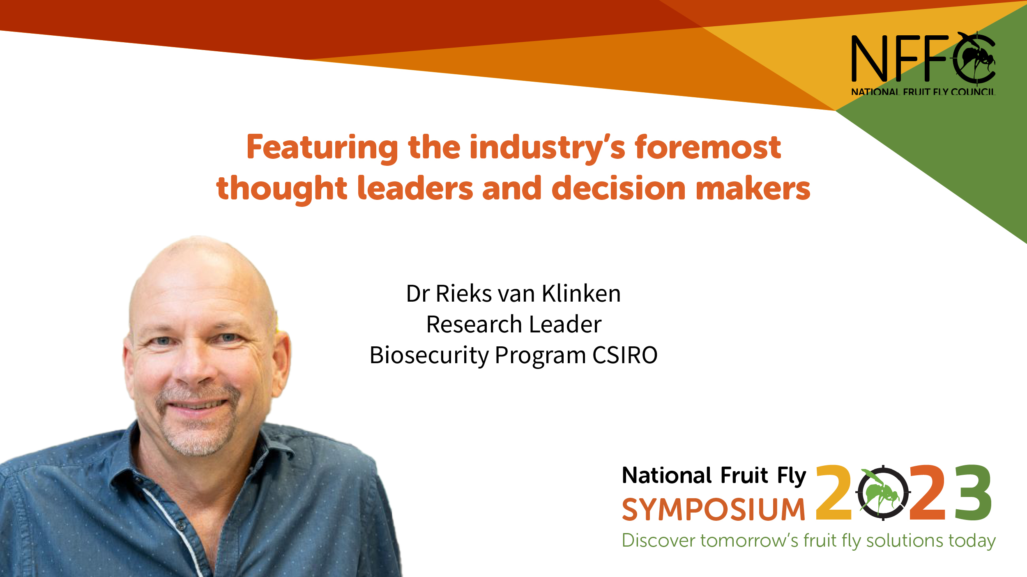
15 July | We are excited for Bec Lang, a facilitator who specialises in designing and delivering engagement initiatives, to keep us on track at the upcoming #fruitflysymposium2023. Check out the program and register: https://ow.ly/ZHYb50OTlnO  #preventfruitfly #viewoverthehorizon  @Hort_AU | 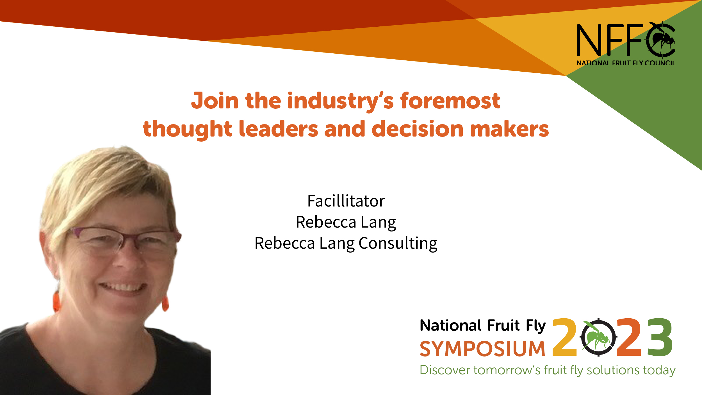
19 July | The #fruitflysymposium2023 starts tomorrow. It’s not too late to register for online attendance. Be part of the national #fruitfly discussion.  Register now: https://ow.ly/ZHYb50OTlnO  #preventfruitfly #viewoverthehorizon  @Hort_AU | 